# **Network Forensic Analysis Report**

## **Time Thieves**

You must inspect your traffic capture to answer the following questions:

1. What is the domain name of the users' custom site?
   * Frank-n-ted.com
2. What is the IP address of the Domain Controller (DC) of the AD network?
   * 10.6.12.157
3. What is the name of the malware downloaded to the 10.6.12.203 machine?
   * Once you have found the file, export it to your Kali machine's desktop.
4. Upload the file to [VirusTotal.com](https://www.virustotal.com/gui/).
5. What kind of malware is this classified as?
   * Trojan

## **Vulnerable Windows Machine**

1. Find the following information about the infected Windows machine:
   * Hostname ROTTERDAM-PC
   * IP address: 172.16.14.205
   * MAC address: 00.59.07.b0.63.a4
2. What is the username of the Windows user whose computer is infected?
   * matthijs.devries@rotterdamPC
3. What are the IP addresses used in the actual infection traffic?
   * 172.16.4.205

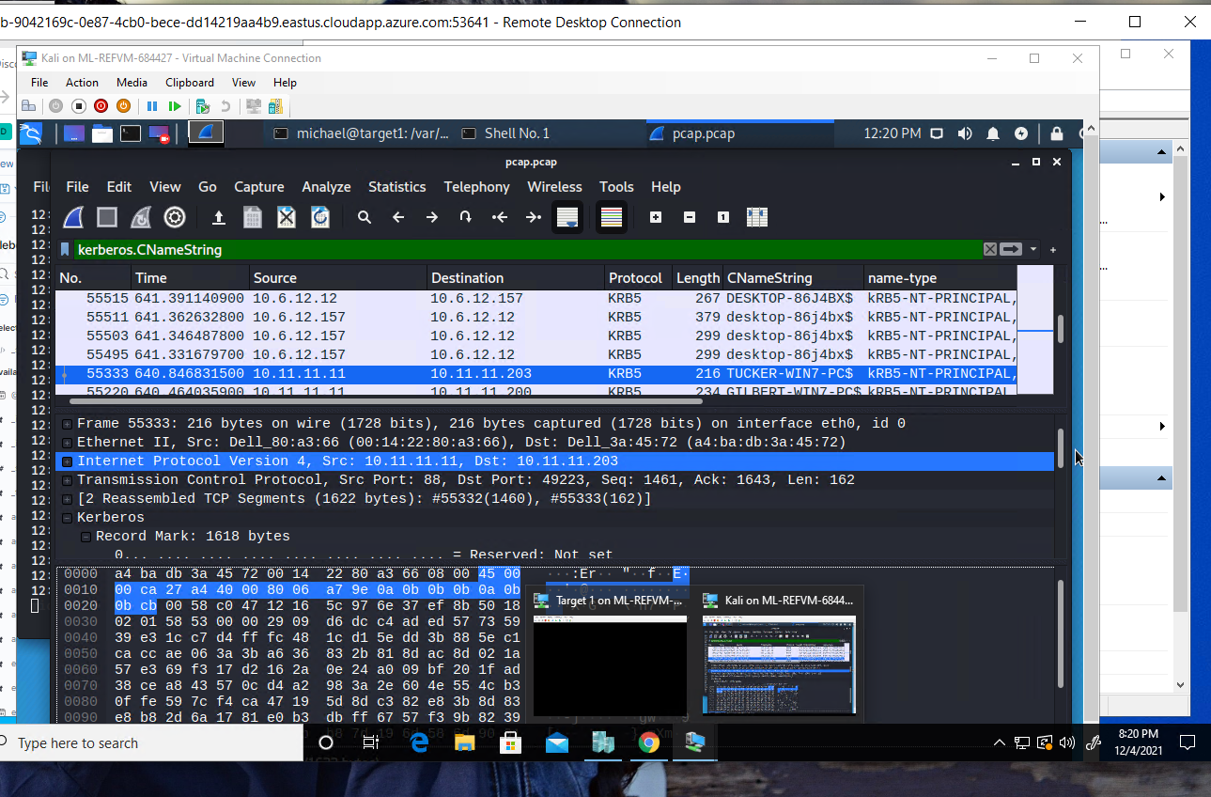

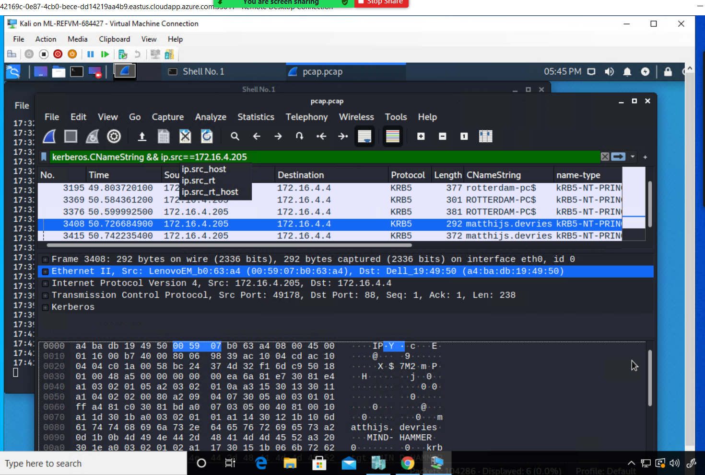

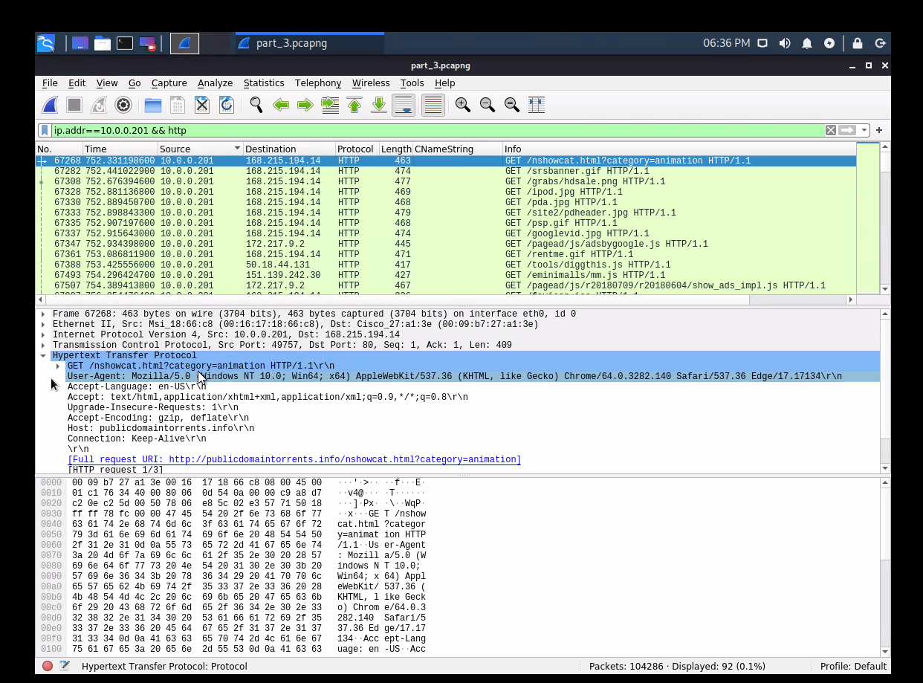

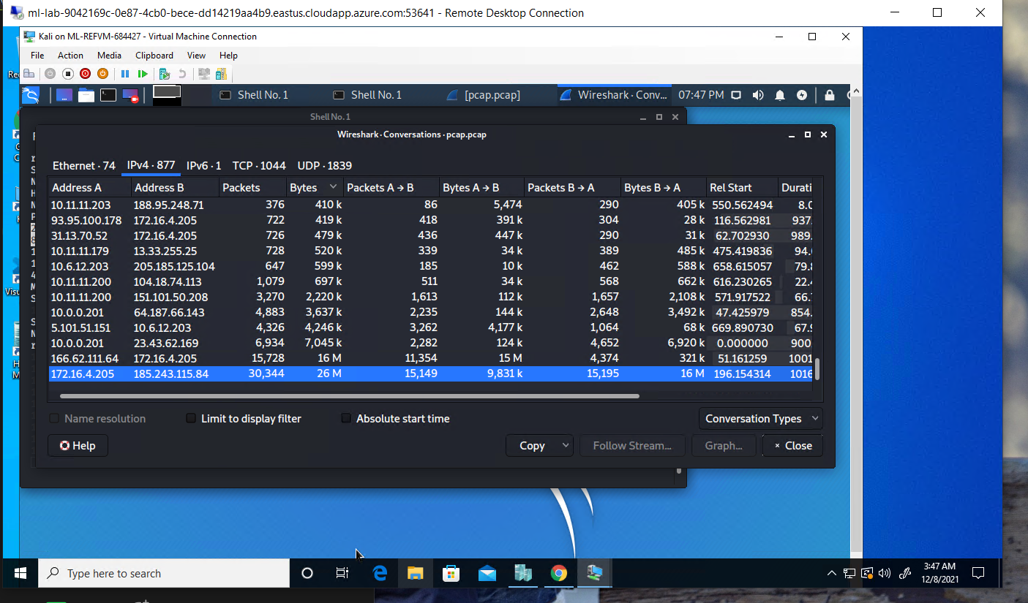

1. As a bonus, retrieve the desktop background of the Windows host.

## 

## 

## **Illegal Downloads**

1. Find the following information about the machine with IP address 10.0.0.201:  
   * MAC address 00:16:17:18:66c8
   * Windows username - blanco
   * OS version: Windows NT 10
2. Which torrent file did the user download?
   * reservation.avi.torrent